**SC2006 Software Engineering**



**Lab#2 Deliverables**

| Group Members (Group 45) | |
| --- | --- |
| Name | Matriculation No. |
| Kua Li Min | U2322513H |
| Hudzaifah Bin Muhammad Taufiq | U2320600F |
| Cheng Hui Wen | U2322123G |
| Ng Hoe Ping | U2321991F |
| Seow Jia Xian Jackson | U2322995F |
| Chua Ze Ming | U2321797B |
| Zhang Yuxuan | U2321475L |

Table of Contents

**1.0 Use Case Diagram 3**

2.0 Use Case Description 4

2.1 User Account Management System 4

2.2 Review System 11

2.3 Listing System 14

2.4 Browsing System 21

2.5 Payment System 31

**3.0 Class Diagram 34**

**4.0 State Machine Diagram 34**

**5.0 Sequence Diagram 35**

5.1 Account Management 35

5.2 Browse 37

5.3 Offer 38

5.4 Review 39

## 1.0 Use Case Diagram

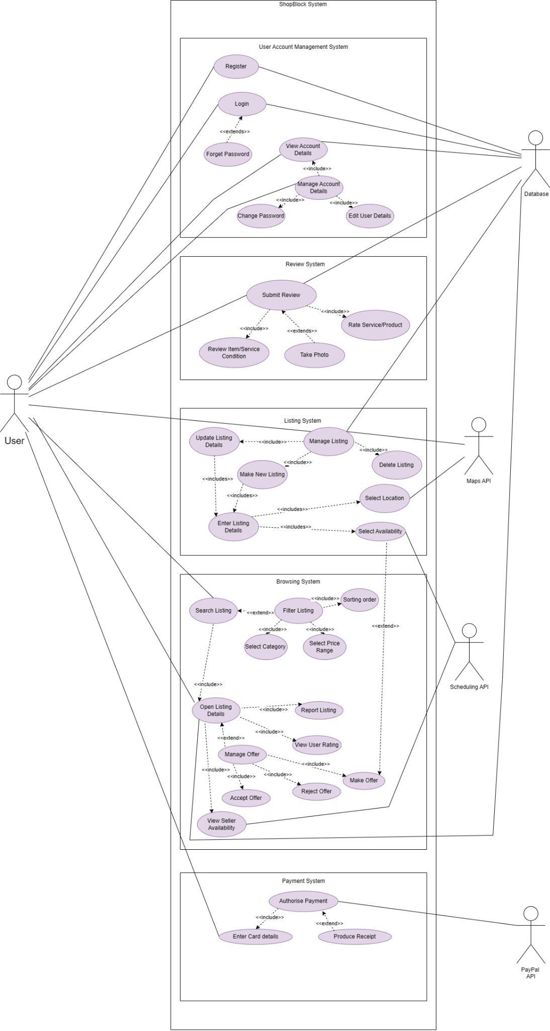

## 2.0 Use Case Description

Key:

Frequency 1-5, 1 = Low 5 = Very Frequent

### 

### 2.1 User Account Management System

| Use Case ID: | **USER_UC_1** | | |
| --- | --- | --- | --- |
| Use Case Name: | **Register** | | |
| Created By: | **Ng Hoe Ping** | Last Updated By: | **Ng Hoe Ping** |
| Date Created: | **1/9/2024** | Date Last Updated: | **1/9/2024** |

| Actor: | **User** |
| --- | --- |
| Description: | Allows a non-User to create and register a new account. |
| Preconditions: | 1. **User must not be an existing registered user in the system.** 2. **User must have the necessary personal information to create an account.** |
| Postconditions: | 1. **Account details are stored in the database to be retrieved when prompted** |
| Priority: |  |
| Frequency of Use: | **1** |
| Flow of Events: | 1. **User inputs required information: Username, Phone Number, Password.** 2. **System validates the information with existing information in the database.** 3. **System creates the account if no conflicting username/phone number is found.** 4. **System updates account information in database.** 5. **System directs the user to the login page.** |
| Alternative Flows: | **AF-S1-a. User account already exists: Phone number taken.**   1. **System displays “An account with this phone number exists!”** 2. **System prompts user to “Create New Account”, “Log In” or “Forget Password”** 3. **If “Create New Account”, then continue from main flow step 1.** 4. **If “Log In”, then system directs to log in page to continue from Login (USER_UC_2)** 5. **If “Forget Password”, then system will direct to “forget password page” (USER_UC_3)**   **AF-S1-b. Username already taken**   1. **System displays “Username already taken”** 2. **System prompts user to input a different username.** 3. **Continue from main flow step 1.**   **AF-S1-c. Password does not meet requirements.**   1. **System displays “Password does not meet requirements!”** 2. **System displays “Please input a password of at least 1 special character, mixed case and at least 8 characters long” message.** 3. **Continue from main flow step 1.** |
| Exceptions: |  |
| Includes: |  |
| Extends: |  |
| Special Requirements: |  |
| Assumptions: |  |
| Notes and Issues: |  |

| Use Case ID: | **USER_UC_2** | | |
| --- | --- | --- | --- |
| Use Case Name: | **Login** | | |
| Created By: | **Ng Hoe Ping** | Last Updated By: | **Ng Hoe Ping** |
| Date Created: | **1/9/2024** | Date Last Updated: | **1/9/2024** |

| Actor: | **User** |
| --- | --- |
| Description: | Allows an existing registered user to log in to the website with their personal information. |
| Preconditions: | 1. **User must be an existing registered user in the database.** 2. **User must have the necessary personal information to log in to the account.** |
| Postconditions: |  |
| Priority: |  |
| Frequency of Use: | **3** |
| Flow of Events: | 1. **User inputs required information: username and password.** 2. **System validates the information with existing information in the database.** 3. **System logs in to the account if the inputted information matches the database.** 4. **System directs the user to the main page.** |
| Alternative Flows: | **AF-S1-a. Username found but incorrect password**   1. **System displays “Incorrect Password! Please try again”** 2. **System prompts the user to input the password again.** 3. **Continue to Main Flow Step 1.** 4. **After three unsuccessful attempts, the system prompts the user with “Forget Password?”.** 5. **If User chooses to “Forget Password” User will be directed to the “Forget Password” (USER_UC_3) Page to reset their password**   **AF-S1-b. Ignoring the “Forget Password” prompt**   1. **System displays “Incorrect Password! Please try again”** 2. **System prompts the user to input the password again.** 3. **Continue to Main Flow Step 1.** 4. **After three unsuccessful attempts, the system prompts the user with “Your account will be locked after two more attempts. Forget password?”.** 5. **If User chooses to ignore the prompt, the user will be allowed to re-attempt to log in to the account.** 6. **If User successfully input the correct corresponding password, the user will be directed to the main page.** 7. **If User has two more failed attempts (total of 5 unsuccessful tries), the user will be locked out from the account.** 8. **The system prompts the user with “Your account has been temporarily locked for 5 mins. Please try again later or reset your password”.** 9. **If User chooses to “Forget Password” User will be directed to the “Forget Password” (USER_UC_3) Page to reset their password** 10. **User can choose to try again later in 5 mins, continue from Main Flow Step 1**   **AF-S1-c. Username not found!**   1. **System displays “Username not found”** 2. **System prompts the user to input username again.** 3. **Continue from Main Flow Step 1** |
| Exceptions: |  |
| Includes: |  |
| Extends: | Forget Password **(USER_UC_3)** |
| Special Requirements: |  |
| Assumptions: |  |
| Notes and Issues: |  |

| Use Case ID: | **USER_UC_3** | | |
| --- | --- | --- | --- |
| Use Case Name: | **Forget Password** | | |
| Created By: | **Ng Hoe Ping** | Last Updated By: | **Ng Hoe Ping** |
| Date Created: | **1/9/2024** | Date Last Updated: | **1/9/2024** |

| Actor: | **User** |
| --- | --- |
| Description: | Allows an existing registered user to edit their existing password in the database. |
| Preconditions: | 1. **User must be an existing registered user in the database.** 2. **User must have the corresponding email to the registered account.** |
| Postconditions: | 1. **Account details are stored in the database to be retrieved when prompted** |
| Priority: |  |
| Frequency of Use: | **1** |
| Flow of Events: | 1. **User inputs required information: Username and Phone Number** 2. **System validates the information with existing information in the database.** 3. **System prompts user to input new password.** 4. **User successfully resets password.** 5. **User is directed to the Login page (USER_UC_1)** |
| Alternative Flows: | **AF-S1-a. Password does not meet requirements.**   1. **Starting from main flow step 3.** 2. **System displays “Please input a password of at least 1 special character, mixed case and at least 8 characters long” message.** 3. **User inputs valid password and is direct to the Login Page (USER_UC_1)**   **AF-S1-b. Username not found!**   1. **System displays “Username not found”** 2. **System prompts the user to input username again.** 3. **Continue from Main Flow Step 1**   **AF-S1-c. Phone number does not match!**   1. **System displays “Phone number does not match”** 2. **System prompts the user to input phone number again.** 3. **Continue from Main Flow Step 1** |
| Exceptions: |  |
| Includes: |  |
| Extends: |  |
| Special Requirements: |  |
| Assumptions: |  |
| Notes and Issues: |  |

| Use Case ID: | **USER_UC_4** | | |
| --- | --- | --- | --- |
| Use Case Name: | **View Account Details** | | |
| Created By: | **Ng Hoe Ping** | Last Updated By: | **Ng Hoe Ping** |
| Date Created: | **2/9/2024** | Date Last Updated: | **2/9/2024** |

| Actor: | **User** |
| --- | --- |
| Description: | **Allows a user to view their own individual account details** |
| Preconditions: | 1. **User must be logged in** |
| Postconditions: |  |
| Priority: |  |
| Frequency of Use: | **2** |
| Flow of Events: | 1. **User selects the “View Account Details” option from the main page.** 2. **Users are able to see their username, listing details and reviews and phone number.** 3. **User can choose “Manage Account Details” (USER_UC_5), or choose to go back to the main page.** |
| Alternative Flows: |  |
| Exceptions: |  |
| Includes: | Manage Account Details (**USER_UC_5)** |
| Extends: |  |
| Special Requirements: |  |
| Assumptions: |  |
| Notes and Issues: |  |

| Use Case ID: | **USER_UC_5** | | |
| --- | --- | --- | --- |
| Use Case Name: | **MANAGE ACCOUNT DETAILS** | | |
| Created By: | **Ng Hoe Ping** | Last Updated By: | **Ng Hoe Ping** |
| Date Created: | **2/9/2024** | Date Last Updated: | **2/9/2024** |

| Actor: | **User** |
| --- | --- |
| Description: | Allows a user to read/modify their own individual account details. |
| Preconditions: | 1. **User must be logged in** |
| Postconditions: |  |
| Priority: |  |
| Frequency of Use: | **2** |
| Flow of Events: | 1. **User can choose to edit their individual data by accessing “Change Password” (USER_UC6) or “Edit User Data” (USER_UC_7)** |
| Alternative Flows: |  |
| Exceptions: |  |
| Includes: | Change Password (**USER_UC_6)**  Edit User Data (**USER_UC_7)** |
| Extends: |  |
| Special Requirements: |  |
| Assumptions: |  |
| Notes and Issues: |  |

| Use Case ID: | **USER_UC_6** | | |
| --- | --- | --- | --- |
| Use Case Name: | **Change Password** | | |
| Created By: | **Ng Hoe Ping** | Last Updated By: | **Ng Hoe Ping** |
| Date Created: | **2/9/2024** | Date Last Updated: | **2/9/2024** |

| Actor: | **User** |
| --- | --- |
| Description: | Allows a user to change their existing password |
| Preconditions: | 1. **User must be logged in** |
| Postconditions: | 1. **Account details are stored in the database to be retrieved when prompted** |
| Priority: |  |
| Frequency of Use: | **1** |
| Flow of Events: | 1. **System prompts the user to input current account password.** 2. **System validates the password with existing information in the database.** 3. **System then prompts the user to input a new password twice.** 4. **User inputs a new password twice** 5. **System prompts “Password successfully changed!”** 6. **System updates the new password, overwriting the existing information in the database.** |
| Alternative Flows: | **AF-S1-a. Current Password does not match**   1. **Starting from main flow step 2.** 2. **System prompts “Password does not match!”** 3. **Continue from main flow step 1.**   **AF-S1-b. Password does not meet requirements.**   1. **Starting from main flow step 4.** 2. **System displays “Please input a password of at least 1 special character, mixed case and at least 8 characters long” message.** 3. **User inputs a new password** 4. **System prompts “Password successfully changed!”** 5. **System updates the new password, overwriting the existing information in the database**   **AF-S1-b. “Confirm Password does not match new password”**   1. **Starting from main flow step 4.** 2. **System displays “Your new password does not match!” message.** 3. **User re-inputs the password.** 4. **System prompts “Password successfully changed!”** 5. **System updates the new password, overwriting the existing information in the database.** |
| Exceptions: |  |
| Includes: |  |
| Extends: |  |
| Special Requirements: |  |
| Assumptions: |  |
| Notes and Issues: |  |

| Use Case ID: | **USER_UC_7** | | |
| --- | --- | --- | --- |
| Use Case Name: | **Edit User Details** | | |
| Created By: | **Ng Hoe Ping** | Last Updated By: | **Ng Hoe Ping** |
| Date Created: | **2/9/2024** | Date Last Updated: | **2/9/2024** |

| Actor: | **User** |
| --- | --- |
| Description: | Allows a user to read/modify their own individual account details. |
| Preconditions: | 1. **User must be logged in** |
| Postconditions: |  |
| Priority: |  |
| Frequency of Use: | **1** |
| Flow of Events: | 1. **Users can choose to edit their username, phone number, and profile picture.** 2. **After User edit and confirm changes** 3. **System will prompt “Changes saved!”** 4. **System will direct back to “Manage Account Details” (USER_UC_5)**   **AF-S1-a. Username has been taken**   1. **User chooses a new username and confirm changes** 2. **System displays “Username already taken”** 3. **System prompts User to input a different username.** 4. **Continue from main flow step 2.**   **AF-S1-b. Phone number has been taken**   1. **User chooses a new phone number and confirms changes.** 2. **System displays “An account with this phone number exists!”** 3. **System prompts User to input a new phone number** 4. **Continue from main flow step 2.** |
| Alternative Flows: |  |
| Exceptions: |  |
| Includes: |  |
| Extends: |  |
| Special Requirements: |  |
| Assumptions: |  |
| Notes and Issues: |  |

### 2.2 Review System

| Use Case ID: | **REVIEW_UC_1** | | |
| --- | --- | --- | --- |
| Use Case Name: | **Submit a Review** | | |
| Created By: | **Li Min** | Last Updated By: | **Hudzaifah** |
| Date Created: | **31/8/24** | Date Last Updated: | **23/9/24** |

| Actor: | **User, Database API** |
| --- | --- |
| Description: | **This use case allows a user to submit a review for a service or product. The user provides feedback on the item/service condition and optionally rates the service/item. The user may also choose to take a photo as part of the review.** |
| Preconditions: | 1. **User must be logged in** 2. **User must have completed the product or service** 3. **The system displays the “Rate Service/Product” button** |
| Postconditions: | 1. **Feedback on the item/service condition is included in the review** 2. **Displays a “success message” to a user** |
| Priority: | **High** |
| Frequency of Use: | **Whenever a user completes a product/service, they must submit a rating and review.** |
| Flow of Events: | 1. **The system displays the "Rate Service/Product" button.** 2. **The user clicks the button to initiate the review process.** 3. **The user selects a rating between 1 to 5 stars.** 4. **The user optionally uploads a photo.** 5. **The user enters a text review.** 6. **The user clicks "Submit Review."** 7. **The system validates the input fields and saves the review.** 8. **The system displays a success message to the user.** |
| Alternative Flows: | **AF-S1-a. User leaves ratings blank**   1. **System prompts user to “Please select a rating!”** 2. **Continue from main flow step 1**   **AF-S1-b. User leaves comments blank**   1. **System displays “Please enter some comments!”** 2. **Continue from main flow step 5** |
| Exceptions: | **If a photo is uploaded in the wrong format, the system prompts the user to upload a valid photo.**  **If user fails to submit the required fields (rating/text) the system will highlight the missing fields.** |
| Includes: | **Review Item/Service Condition (REVIEW_UC_2) Rate Service/Product (REVIEW_UC_3)** |
| Extends: | **Take Photo (REVIEW_UC_4)** |
| Special Requirements: |  |
| Assumptions: |  |
| Notes and Issues: |  |

| Use Case ID: | **REVIEW_UC_2** | | |
| --- | --- | --- | --- |
| Use Case Name: | **Review Item/Service Condition** | | |
| Created By: | **Li Min** | Last Updated By: | **Li Min** |
| Date Created: | **31/8/24** | Date Last Updated: | **31/8/24** |

| Actor: | **User** |
| --- | --- |
| Description: | **This use case allows the user to provide feedback on the condition of the item or service being reviewed. This is part of the broader "Submit Review" use case.** |
| Preconditions: | 1. **User must be logged in** 2. **User must have had rented the product** |
| Postconditions: | 1. **Feedback on the item/service condition is included in the review** |
| Priority: |  |
| Frequency of Use: | **3** |
| Flow of Events: | 1. **The user is prompted to describe the condition of the item/service.** 2. **The user provides feedback on the condition** |
| Alternative Flows: |  |
| Exceptions: |  |
| Includes: |  |
| Extends: |  |
| Special Requirements: |  |
| Assumptions: |  |
| Notes and Issues: |  |

| Use Case ID: | **REVIEW_UC_3** | | |
| --- | --- | --- | --- |
| Use Case Name: | **Rate Service/Product** | | |
| Created By: | **Li Min** | Last Updated By: | **Hudzaifah** |
| Date Created: | **31/8/24** | Date Last Updated: | **23/9/24** |

| Actor: | **User** |
| --- | --- |
| Description: | **This use case allows the user to rate the service or product out of 5 stars. This is included as part of the broader "Submit Review" use case.** |
| Preconditions: | 1. **User must be logged in** 2. **User must have had rented the product** |
| Postconditions: | 1. **Review is stored in the system and available for others to view** |
| Priority: | **High** |
| Frequency of Use: | **3** |
| Flow of Events: | 1. **The system prompts the user to provide a rating out of 5.** 2. **The user selects a rating.** 3. **The system saves the rating.** 4. **The system allows user to proceed with review submission.** |
| Alternative Flows: | **If no rating, then system prompts user to choose rating.** |
| Exceptions: |  |
| Includes: |  |
| Extends: |  |
| Special Requirements: |  |
| Assumptions: | **System will display a rating scale (stars format)** |
| Notes and Issues: |  |

| Use Case ID: | **REVIEW_UC_4** | | |
| --- | --- | --- | --- |
| Use Case Name: | **Take Photo** | | |
| Created By: | **Li Min** | Last Updated By: | **Li Min** |
| Date Created: | **31/8/24** | Date Last Updated: | **31/8/24** |

| Actor: | **User** |
| --- | --- |
| Description: | **This use case allows the user to optionally take or upload a photo as part of the review. This extends the "Submit Review" use case.** |
| Preconditions: | 1. **User must be logged in** 2. **User must have had rented the product** |
| Postconditions: | 1. **The photo is included as part of the review.** |
| Priority: |  |
| Frequency of Use: | **2** |
| Flow of Events: | 1. **The system prompts the user to take or upload a photo.** 2. **The user takes or selects a photo from their device.** 3. **The system includes the photo in the review.** |
| Alternative Flows: | **AF-S1-a. Photo fails to upload**   1. **System displays “Photo failed to upload. Please try again.”** 2. **Continue from main flow step 1** |
| Exceptions: |  |
| Includes: |  |
| Extends: |  |
| Special Requirements: |  |
| Assumptions: |  |
| Notes and Issues: |  |

### 2.3 Listing System

| Use Case ID: | **LIST_UC_1** | | |
| --- | --- | --- | --- |
| Use Case Name: | **Manage Listing** | | |
| Created By: | **Hui Wen** | Last Updated By: | **Hui Wen** |
| Date Created: | **1/9/24** | Date Last Updated: | **1/9/24** |

| Actor: | **User, Maps API, Database** |
| --- | --- |
| Description: | **Allows user to create, update, or delete a listing.** |
| Preconditions: | 1. **User must be logged in.** 2. **User must enter all the necessary information.** |
| Postconditions: | 1. **The listing is successfully created, updated, or deleted.** 2. **Any changes made to a listing are reflected in the app and visible to all users.** 3. **The system ensures the listing complies with all necessary validation rules before saving.** |
| Priority: |  |
| Frequency of Use: | **4** |
| Flow of Events: | 1. **The renter navigates to the "Manage Listings" section in the app.** 2. **The renter selects an option to create a new listing, update an existing listing, or delete a listing.** 3. **The renter provides or modifies details such as the title, description, rental price, availability, location, and images.** 4. **The renter submits the changes.** 5. **The system saves the changes and updates the listing information.** 6. **The renter receives a confirmation that the listing has been successfully managed.** |
| Alternative Flows: | **AF-S1-a. User cancels the operation before submission**   1. **System exits listing page and return to home page, and no changes will be saved.**   **AF-S1-b System encounters an error upon submission(e.g., database connectivity issues)**   1. **Notifies the user with a prompt telling them to resubmit.** |
| Exceptions: |  |
| Includes: | Update Listing Details  Make New Listing  Delete Listing |
| Extends: |  |
| Special Requirements: |  |
| Assumptions: |  |
| Notes and Issues: |  |

| Use Case ID: | **LIST_UC_2** | | |
| --- | --- | --- | --- |
| Use Case Name: | **Make New Listing** | | |
| Created By: | **Hui Wen** | Last Updated By: | **Hui Wen** |
| Date Created: | **1/9/24** | Date Last Updated: | **1/9/24** |

| Actor: | **User** |
| --- | --- |
| Description: | **Allows user to create a new listing to showcase the item/service they want to rent out.** |
| Preconditions: | 1. **User must be logged in.** 2. **User must enter all the necessary information.** |
| Postconditions: | 1. **Listing is stored in the system and available for other users to view** |
| Priority: |  |
| Frequency of Use: | **3** |
| Flow of Events: | 1. **User selects create listing option** 2. **System prompts user to input details (Covered in Enter Listing Details)** 3. **User submits listing.** 4. **System saves the listing and displays it on the user’s profile. The listing is made available for other users to view.** |
| Alternative Flows: | **AF-S1-a. User leaves Title/description/rental price/location blank and tries to submit listing**   1. **System displays “Must include Title/description/rental price/location ”** 2. **continue from main flow step 2**   **AF-S1-b. User leaves the create listing page before submitting**   1. **System prompts user “Are you sure you want to leave and delete listing?”** 2. **If user selects yes, all information entered is deleted and user will return to Manage Listing page** 3. **If user selects no continue main flow from step 2.** |
| Exceptions: |  |
| Includes: | Enter Listing Details |
| Extends: |  |
| Special Requirements: |  |
| Assumptions: |  |
| Notes and Issues: |  |

| Use Case ID: | **LIST_UC_3** | | |
| --- | --- | --- | --- |
| Use Case Name: | **Update Listing Details** | | |
| Created By: | **Hui Wen** | Last Updated By: | **Hui Wen** |
| Date Created: | **1/9/24** | Date Last Updated: | **1/9/24** |

| Actor: | **User** |
| --- | --- |
| Description: | **Allows user to edit their existing listings.** |
| Preconditions: | 1. **User must be logged in.** 2. **User must select an existing listing that they had previously created.** |
| Postconditions: | 1. **Edits to listing is updated and stored in the system and available for other users to view** |
| Priority: |  |
| Frequency of Use: | **3** |
| Flow of Events: | 1. **User selects update listing option** 2. **User edits the information in their listing such as changing the title, description, rating, photo.** 3. **User confirms listing update.** 4. **System saves the edits and displays it on the user’s profile. The updated listing is made available for other users to view.** |
| Alternative Flows: | **AF-S1-a. User leaves Title/description/rental price/location blank and tries to confirm listing update**   1. **System displays “Must include Title/description/rental price/location ”** 2. **continue from main flow step 2**   **AF-S1-b. User leaves the update listing page before submitting**   1. **System prompts user “Are you sure you want to leave and delete changes?”** 2. **If user selects yes, all changes are deleted and user will return to ____ page. The listing will not be updated and the original listing remains** 3. **If user selects no continue main flow from step 2.** |
| Exceptions: |  |
| Includes: | Enter Listing Details |
| Extends: |  |
| Special Requirements: |  |
| Assumptions: |  |
| Notes and Issues: |  |

| Use Case ID: | **LIST_UC_4** | | |
| --- | --- | --- | --- |
| Use Case Name: | **Delete Listing** | | |
| Created By: | **Hui Wen** | Last Updated By: | **Hui Wen** |
| Date Created: | **1/9/24** | Date Last Updated: | **1/9/24** |

| Actor: | **User** |
| --- | --- |
| Description: | **Allows the user to delete their own existing listing.** |
| Preconditions: | 1. **User must be logged in.** 2. **User must select an existing listing that they had previously created.** |
| Postconditions: | 1. **Listing is removed from the system and users are no longer able to view it.** |
| Priority: |  |
| Frequency of Use: | **3** |
| Flow of Events: | 1. **User selects delete listing option** 2. **System prompts user to confirm deletion.** 3. **User confirms listing deletion.** 4. **Listing is deleted from the system and is no longer available for other users to view.** |
| Alternative Flows: | **AF-S1-a. User selects “cancel” when being prompted to confirm deletion**   1. **System cancels the deletion, listing is not deleted.** 2. **User is returned to the original listing page.** |
| Exceptions: |  |
| Includes: |  |
| Extends: |  |
| Special Requirements: |  |
| Assumptions: |  |
| Notes and Issues: |  |

| Use Case ID: | **LIST_UC_5** | | |
| --- | --- | --- | --- |
| Use Case Name: | **Select Location** | | |
| Created By: | **Hui Wen** | Last Updated By: | **Hui Wen** |
| Date Created: | **1/9/24** | Date Last Updated: | **1/9/24** |

| Actor: | **User, Maps API** |
| --- | --- |
| Description: | **Allows user to select their location that a rentee can use when deciding to rent.** |
| Preconditions: | 1. **User must be logged in.** 2. **User must allow locations to be used** |
| Postconditions: | 1. **The selected location is stored as part of the listing and is visible to all users** |
| Priority: |  |
| Frequency of Use: | **3** |
| Flow of Events: | 1. **System presents a map interface with options to search for locations by entering an address, or using the device’s GPS to determine the current location.** 2. **User enters location** 3. **System asks the user to confirm the selection.** 4. **User reviews the selected location and confirms the location.** 5. **System saves the selected location as part of the rental request.** |
| Alternative Flows: | **AF-S1-a. User Cancels Location Selection:**   1. **At any point during the location selection process, the user can cancel the selected colation** 2. **The system exits the location selection process and returns the user to the previous screen without saving any location data.** 3. **Continue from main flow 1**   **AF-S1-b. Location Not Found:**   1. **If the system is unable to find the location entered by the user, an error message is displayed which prompts the user to re-enter the address or use the device’s GPS location.** 2. **Continue from main flow 1.**   **AF-S1-c. GPS Access Denied:**   1. **The system allows the user to enter a location manually.** 2. **Continue from main flow 1.** |
| Exceptions: |  |
| Includes: |  |
| Extends: |  |
| Special Requirements: |  |
| Assumptions: |  |
| Notes and Issues: |  |

| Use Case ID: | **LIST_UC_6** | | |
| --- | --- | --- | --- |
| Use Case Name: | **Enter Listing Details** | | |
| Created By: | **Ze Ming** | Last Updated By: | **Ze Ming** |
| Date Created: | **1/9/2024** | Date Last Updated: | **7/9/2024** |

| Actor: | **User** |
| --- | --- |
| Description: | **Enter Listing Details allows user to enter details so that they are able to find related items to borrow** |
| Preconditions: | 1. **User must be logged in** 2. **A listing must have been clicked** |
| Postconditions: | 1. **User selects Listing location** 2. **User selects Availability** |
| Priority: |  |
| Frequency of Use: | **1** |
| Flow of Events: | 1. **User clicks on listing name and inputs listing name** 2. **User clicks on listing details and inputs listing details** 3. **System validates that the input** 4. **User can then select listing location or availability** |
| Alternative Flows: | **AF-S1-a. User cancels enter listing details:**   1. **User can click back button on the browser tab at any time** 2. **The system will exit the page and brings the user back to the manage listing page** 3. **Continue from Manage Listing** |
| Exceptions: |  |
| Includes: | **Select Location (LIST_UC_5)**  **Select Availability (LIST_UC_7)** |
| Extends: |  |
| Special Requirements: |  |
| Assumptions: |  |
| Notes and Issues: |  |

| Use Case ID: | **LIST_UC_7** | | |
| --- | --- | --- | --- |
| Use Case Name: | **Select Availability** | | |
| Created By: | **Ze Ming** | Last Updated By: | **Ze Ming** |
| Date Created: | **1/9/2024** | Date Last Updated: | **7/9/2024** |

| Actor: | **User** |
| --- | --- |
| Description: | **Select Availability allows the user to select an available time slot from the listing provider to schedule a date and time** |
| Preconditions: | 1. **User must be logged in** 2. **A listing must have been clicked** 3. **User has entered listing details** |
| Postconditions: |  |
| Priority: |  |
| Frequency of Use: | **2** |
| Flow of Events: | 1. **User clicks to select availability** 2. **System will redirect user to scheduling webpage** 3. **User can then click on which date and time to schedule the appointment** 4. **System will then give the user an option to add to their calendar** |
| Alternative Flows: | **AF-S1-a. User cancels select availability:**   1. **User can click back button on the browser tab at any time** 2. **The system will exit the page and brings the user back to the manage listing page** 3. **Continue from Manage Listing** |
| Exceptions: |  |
| Includes: |  |
| Extends: | **Make Offer (BROWSE_UC_11)** |
| Special Requirements: |  |
| Assumptions: |  |
| Notes and Issues: |  |

### 2.4 Browsing System

| Use Case ID: | **BROWSE_UC_1** | | |
| --- | --- | --- | --- |
| Use Case Name: | **Search Listing** | | |
| Created By: | **Yuxuan** | Last Updated By: | **Yuxuan** |
| Date Created: | **3/9/24** | Date Last Updated: | **7/9/24** |

| Actor: | **User** |
| --- | --- |
| Description: | **The Search Listing function allows the user to search for goods and services currently available on the web app. Users input keywords to search the listings, and the system filters and displays results that match the search criteria.** |
| Preconditions: |  |
| Postconditions: | 1. **System will display the relevant items or services that match the keywords entered by the user.** |
| Priority: |  |
| Frequency of Use: | **5** |
| Flow of Events: | 1. **System prompts the user to enter the keyword into the search bar.** 2. **User clicks the search button to initiate the search.** 3. **System processes the search request and retrieves listings that match the entered keywords.** 4. **System displays a list of relevant listings based on the search results.** |
| Alternative Flows: | **AF-S1-a. No search results found**  **Trigger: The system finds no listings that match the entered keywords.**   1. **The system displays a message: "No listings found matching your search criteria."** 2. **The system suggests related search terms or prompts the user to broaden their search.** 3. **Users can modify the keywords and initiate a new search.** 4. **continue to main flow step 3** |
| Exceptions: |  |
| Includes: | **Open Listing Details ( BROWSE_UC_6)** |
| Extends: | **Filter Listing (BROWSE_UC_2)** |
| Special Requirements: |  |
| Assumptions: |  |
| Notes and Issues: |  |

| Use Case ID: | **BROWSE_UC_2** | | |
| --- | --- | --- | --- |
| Use Case Name: | **Filter Listing** | | |
| Created By: | **Yuxuan** | Last Updated By: | **Yuxuan** |
| Date Created: | **3/9/24** | Date Last Updated: | **7/9/24** |

| Actor: | **User** |
| --- | --- |
| Description: | **The filter listing functionality allows users to apply multiple filters to refine the scope of listings and narrow down the search results. This helps users find relevant items or services efficiently based on their specific needs. Available filters may include category, price range, location, availability, and sorting order.** |
| Preconditions: | **.** |
| Postconditions: | 1. **The system displays listings that match all the selected filters.** 2. **If no listings match the applied filters, the system informs the user accordingly.** |
| Priority: |  |
| Frequency of Use: | **4** |
| Flow of Events: | 1. **The system displays a "Filter" button on the web page.** 2. **System prompts the user to click the "Filter" button, and the system presents a list of available filter options.** 3. **System prompts the user to select multiple filters.** 4. **User clicks the “Apply” button to apply the filters.** 5. **System processes the filter selections and refreshes the listing page to show only the items or services that meet the selected criteria.** |
| Alternative Flows: | **AF-S1-a. Incompatible filters**  **Trigger: The user selects incompatible filters**   1. **The system detects conflicting filter criteria.** 2. **The system displays a warning message: "Selected filters are incompatible. Please choose again."** 3. **The user corrects the filter selection and applies the new filters.** 4. **Continues from main flow step 5** |
| Exceptions: |  |
| Includes: | **Select Category (BROWSE_UC_3)**  **Select Price Range (BROWSE_UC_4)**  **Sorting order (BROWSE_UC_5)** |
| Extends: |  |
| Special Requirements: |  |
| Assumptions: |  |
| Notes and Issues: |  |

| Use Case ID: | **BROWSE_UC_3** | | |
| --- | --- | --- | --- |
| Use Case Name: | **Select Category** | | |
| Created By: | **Yuxuan** | Last Updated By: | **Yuxuan** |
| Date Created: | **3/9/24** | Date Last Updated: | **7/9/24** |

| Actor: | **User** |
| --- | --- |
| Description: | **Users can select multiple categories from a predefined list to filter and search for relevant items or services. The system will display items or services based on the selected categories, allowing users to narrow down their search.** |
| Preconditions: |  |
| Postconditions: | 1. **The system displays a list of items or services that match the categories selected by the user.** 2. **If no listings match the categories, the system notifies the user and prompts for changes to the search.** |
| Priority: |  |
| Frequency of Use: | **3** |
| Flow of Events: | 1. **System prompts the user to tick multiple category boxes.** 2. **System prompts the user to confirm the category selection by clicking the "Apply" button.** 3. **System retrieves listings that match the selected categories and displays them to the user.** 4. **System display listings that match the filters.** |
| Alternative Flows: | **AF-S1-a. No available listings for current filters applied**   1. **System will display the warning message “No available listing and please enter again” if filters applied have filtered out all listings available** 2. **User must clear the current filters** 3. **Continue from main flow step 1** |
| Exceptions: |  |
| Includes: |  |
| Extends: |  |
| Special Requirements: |  |
| Assumptions: |  |
| Notes and Issues: |  |

| Use Case ID: | **BROWSE_UC_4** | | |
| --- | --- | --- | --- |
| Use Case Name: | **Select Price Range** | | |
| Created By: | **Yuxuan** | Last Updated By: | **Yuxuan** |
| Date Created: | **3/9/24** | Date Last Updated: | **7/9/24** |

| Actor: | **User** |
| --- | --- |
| Description: | **The user specifies a price range for the listings by entering minimum and maximum price values and selecting a relevant time unit (hourly, daily, or weekly). The system will filter and display listings that match the specified price range and time unit.** |
| Preconditions: |  |
| Postconditions: | 1. **The system displays listings that fall within the specified price range and time unit.** |
| Priority: |  |
| Frequency of Use: | **3** |
| Flow of Events: | 1. **System prompts the user to select the time unit of pricing.** 2. **System prompts the user to key in minimum and maximum price values** 3. **User enters minimum and maximum price values.** 4. **Users click the “Apply” button to apply the filters.** 5. **The system processes the request and displays listings that match the price range and time unit criteria.** 6. **System redirects the user to the landing page with all the listings that match the price range filters.** |
| Alternative Flows: | **AF-S1-a. No listing found**  **Trigger: No listings are available that match the specified price range and time unit.**   1. **The system displays a message: "No listings found for the selected price range and time unit."** 2. **Users modify the filters to search again.** 3. **Continue from main flow step 4** |
| Exceptions: |  |
| Includes: |  |
| Extends: |  |
| Special Requirements: |  |
| Assumptions: |  |
| Notes and Issues: |  |

| Use Case ID: | **BROWSE_UC_5** | | |
| --- | --- | --- | --- |
| Use Case Name: | **Sorting order** | | |
| Created By: | **Yuxuan** | Last Updated By: | **Yuxuan** |
| Date Created: | **3/9/24** | Date Last Updated: | **7/9/24** |

| Actor: | **User** |
| --- | --- |
| Description: | **System allows users to sort listings based on various sorting metrics, such as distance, price or user rating. Users can choose to sort listings in ascending or descending order based on the selected metric.** |
| Preconditions: |  |
| Postconditions: | 1. **System will display the listings in sorted order based on the sorting metrics chosen** |
| Priority: |  |
| Frequency of Use: | **3** |
| Flow of Events: | 1. **System prompts the user to select rate (per hour, day, or week)** 2. **User selects the rate** 3. **System prompts the user to select either ascending or descending** 4. **User enters their choices** 5. **User confirms the selection by clicking “Apply”.** 6. **System displays listings sorted according to the selected metrics and order.** |
| Alternative Flows: | **AF-S1-a. No listing to sort**  **Trigger: There are no listings available to sort when the user attempts to apply sorting**   1. **The system displays a message: "No listings available to sort."** 2. **System prompts the user to either modify their search criteria or return to the search page to generate listings.** 3. **Continue from main flow step 3** |
| Exceptions: |  |
| Includes: |  |
| Extends: |  |
| Special Requirements: |  |
| Assumptions: |  |
| Notes and Issues: |  |

| Use Case ID: | **BROWSE_UC_6** | | |
| --- | --- | --- | --- |
| Use Case Name: | **Open Listing Details** | | |
| Created By: | **Seow Jia Xian** | Last Updated By: | **Seow Jia Xian** |
| Date Created: | **1/9/24** | Date Last Updated: | **1/9/24** |

| Actor: | **User** |
| --- | --- |
| Description: | **Open Listing Details allows the user to view listing details regarding a product** |
| Preconditions: |  |
| Postconditions: | 1. **User is able to view the details of the product** |
| Priority: |  |
| Frequency of Use: | **4** |
| Flow of Events: | 1. **User clicks on a product** 2. **System redirects user to a new page displaying listing details of the product as well as actions** |
| Alternative Flows: |  |
| Exceptions: |  |
| Includes: | **Report Listing, View User Rating, View Seller Availability** |
| Extends: | **Manage Offer** |
| Special Requirements: |  |
| Assumptions: |  |
| Notes and Issues: |  |

| Use Case ID: | **BROWSE_UC_7** | | |
| --- | --- | --- | --- |
| Use Case Name: | **Report Listing** | | |
| Created By: | **Seow Jia Xian** | Last Updated By: | **Seow Jia Xian** |
| Date Created: | **1/9/24** | Date Last Updated: | **1/9/24** |

| Actor: | **User** |
| --- | --- |
| Description: | **Report Listing allows users to report a listing that is deemed suspicious or illegal** |
| Preconditions: | 1. **User must have an User account** 2. **User must have clicked on the listed product that they wish to report** |
| Postconditions: | 1. **Listed product is removed from the shop and the account associated with it may be banned** |
| Priority: |  |
| Frequency of Use: | **1** |
| Flow of Events: | 1. **User clicks on the report button** 2. **Report Listing pop-up window appears** 3. **User enters details on violations/community guidelines that the listed product has invoked** 4. **User submits the information** 5. **System will do a review of the report and log the event** 6. **Review team will remove the listed product and ban the account associated with it if necessary** |
| Alternative Flows: | **AF-S1-a.**  **User clicks on the X button on the Report Listing pop-up window which causes it to be closed** |
| Exceptions: |  |
| Includes: |  |
| Extends: |  |
| Special Requirements: |  |
| Assumptions: |  |
| Notes and Issues: |  |

| Use Case ID: | **BROWSE_UC_8** | | |
| --- | --- | --- | --- |
| Use Case Name: | **View Seller Availability** | | |
| Created By: | **Seow Jia Xian** | Last Updated By: | **Seow Jia Xian** |
| Date Created: | **1/9/24** | Date Last Updated: | **1/9/24** |

| Actor: | **User** |
| --- | --- |
| Description: | **View Seller Availability allows users to view when the seller is available to allow collection of the item for the user (customer)** |
| Preconditions: | 1. **User must have clicked on the view availability button on the product page** |
| Postconditions: | 1. **A calendar is displayed. Available dates are shown to the user for collection** |
| Priority: |  |
| Frequency of Use: | **3** |
| Flow of Events: | 1. **User clicks on the view availability button** 2. **System redirects user to a new page** 3. **System retrieves data from the scheduling API to display on the new page** 4. **System displays a calendar with the available dates shown for user to collect the product** |
| Alternative Flows: |  |
| Exceptions: |  |
| Includes: |  |
| Extends: |  |
| Special Requirements: |  |
| Assumptions: |  |
| Notes and Issues: |  |

| Use Case ID: | **BROWSE_UC_9** | | |
| --- | --- | --- | --- |
| Use Case Name: | **View User Ratings** | | |
| Created By: | **Seow Jia Xian** | Last Updated By: | **Seow Jia Xian** |
| Date Created: | **1/9/24** | Date Last Updated: | **1/9/24** |

| Actor: | **User** |
| --- | --- |
| Description: | **View User Ratings allows users (customer) to view the user ratings/reviews of the seller. User ratings will include ratings ranging from 1-5 stars from past deals/transactions completed by the seller** |
| Preconditions: | 1. **User must have an User account** 2. **User must have clicked on the view user ratings button on the product page** |
| Postconditions: | 1. **Past deals completed by the seller with the user ratings and comments is displayed to the user (customer)** |
| Priority: |  |
| Frequency of Use: | **3** |
| Flow of Events: | 1. **User clicks on the view user ratings button** 2. **System redirects the user to the renter’s profile page which contains the reviews** 3. **System displays the information to the user** |
| Alternative Flows: |  |
| Exceptions: |  |
| Includes: |  |
| Extends: |  |
| Special Requirements: |  |
| Assumptions: |  |
| Notes and Issues: |  |

| Use Case ID: | **BROWSE_UC_10** | | |
| --- | --- | --- | --- |
| Use Case Name: | **Manage Offer** | | |
| Created By: | **Seow Jia Xian** | Last Updated By: | **Seow Jia Xian** |
| Date Created: | **1/9/24** | Date Last Updated: | **1/9/24** |

| Actor: | **User** |
| --- | --- |
| Description: | **Manage offer allows the user to make/accept/reject offers. Typically, the renter is the only party allowed to accept or reject offers while the rentee is only allowed to make offers.** |
| Preconditions: | 1. **User must have an User account** |
| Postconditions: | 1. **User is able to make/accept/reject offers** 2. **Database will be updated with the information** |
| Priority: |  |
| Frequency of Use: | **4** |
| Flow of Events: | 1. **User clicks on a product** 2. **System identifies if user is a renter or rentee** 3. **System will allow user to make offer if user is a rentee; accept/reject offer if user is a renter** 4. **User will make a decision** 5. **System will perform the corresponding tasks according to user’s decision** |
| Alternative Flows: |  |
| Exceptions: |  |
| Includes: | **Make Offer, Accept Offer, Reject Offer** |
| Extends: |  |
| Special Requirements: |  |
| Assumptions: |  |
| Notes and Issues: |  |

| Use Case ID: | **BROWSE_UC_11** | | |
| --- | --- | --- | --- |
| Use Case Name: | **Make Offer** | | |
| Created By: | **Seow Jia Xian** | Last Updated By: | **Seow Jia Xian** |
| Date Created: | **1/9/24** | Date Last Updated: | **1/9/24** |

| Actor: | **User** |
| --- | --- |
| Description: | **Make Offer allows the rentee to make an offer to the renter.** |
| Preconditions: | 1. **User must have an User account** 2. **User must have clicked on the make offer button on the product page** |
| Postconditions: | 1. **The renter is informed of the offer that was made by the user** |
| Priority: |  |
| Frequency of Use: | **3** |
| Flow of Events: | 1. **User sets a price for the renter** 2. **User clicks on the make offer button** 3. **User submits the price to the system** 4. **System informs the renter that an offer has been made** |
| Alternative Flows: |  |
| Exceptions: |  |
| Includes: |  |
| Extends: |  |
| Special Requirements: |  |
| Assumptions: |  |
| Notes and Issues: |  |

| Use Case ID: | **BROWSE_UC_12** | | |
| --- | --- | --- | --- |
| Use Case Name: | **Accept Offer** | | |
| Created By: | **Seow Jia Xian** | Last Updated By: | **Seow Jia Xian** |
| Date Created: | **1/9/24** | Date Last Updated: | **1/9/24** |

| Actor: | **User** |
| --- | --- |
| Description: | **Accept Offer allows the renter to accept an offer that was made by rentee.** |
| Preconditions: | 1. **User must have an User account** 2. **User has received an offer on their product listing** |
| Postconditions: | 1. **The rentee is informed that the offer has been accepted by the renter** 2. **Listing will be marked as sold on the database** |
| Priority: |  |
| Frequency of Use: | **3** |
| Flow of Events: | 1. **User clicks on “Your rentals” on profile icon sidebar** 2. **User (renter) clicks on the product with offers** 3. **User (renter) clicks on the accept offer button** 4. **System will notify the other party (rentee) that the offer has been accepted by the renter** |
| Alternative Flows: | **AF-S1-a.**  **User clicks on the X button on the accept offer window which causes it to be closed** |
| Exceptions: |  |
| Includes: |  |
| Extends: |  |
| Special Requirements: |  |
| Assumptions: |  |
| Notes and Issues: |  |

| Use Case ID: | **BROWSE_UC_13** | | |
| --- | --- | --- | --- |
| Use Case Name: | **Reject Offer** | | |
| Created By: | **Seow Jia Xian** | Last Updated By: | **Seow Jia Xian** |
| Date Created: | **1/9/24** | Date Last Updated: | **1/9/24** |

| Actor: | **User** |
| --- | --- |
| Description: | **Reject Offer allows the renter to reject an offer that was made by the rentee** |
| Preconditions: | 1. **User must have an User account** 2. **User must have clicked on the reject offer button on their product listing page** |
| Postconditions: | 1. **The rentee is informed that the offer has been rejected by the seller** |
| Priority: |  |
| Frequency of Use: | **3** |
| Flow of Events: | 1. **User clicks on “Your rentals” on profile icon sidebar** 2. **User (renter) clicks on the product they want to reject offers** 3. **User (renter) clicks on the reject offer button** 4. **System will notify the other party (rentee) that the offer has been rejected by the seller** |
| Alternative Flows: | **AF-S1-a.**  **User clicks on the X button on the reject offer window which causes it to be closed** |
| Exceptions: |  |
| Includes: |  |
| Extends: |  |
| Special Requirements: |  |
| Assumptions: |  |
| Notes and Issues: |  |

### 2.5 Payment System

| Use Case ID: | **PAY_UC_1** | | |
| --- | --- | --- | --- |
| Use Case Name: | **Authorize Payment** | | |
| Created By: | **Ze Ming** | Last Updated By: | **Ze Ming** |
| Date Created: | **1/9/2024** | Date Last Updated: | **7/9/2024** |

| Actor: | **User, Payment API** |
| --- | --- |
| Description: | **Authorize Payment allows the user to pay for the service** |
| Preconditions: | 1. **User must be logged in** 2. **User must have selected a listing to pay for** |
| Postconditions: |  |
| Priority: |  |
| Frequency of Use: | **2** |
| Flow of Events: | 1. **User will select to pay for the listing** 2. **System will redirect the user to the payment gateway** 3. **User will input their payment methods and pay** 4. **System will verify that payment has been made** |
| Alternative Flows: | **AF-S1-a. User cancels authorize payment:**   1. **User can click back button on the browser tab at any time** 2. **The system will exit the page and brings the user back to the manage listing page** 3. **Continue from Manage Listing** |
| Exceptions: |  |
| Includes: | **Enter Card Details (PAY_UC_2)**  **Produce Receipt (PAY_UC_3)** |
| Extends: |  |
| Special Requirements: |  |
| Assumptions: |  |
| Notes and Issues: |  |

| Use Case ID: | **PAY_UC_2** | | |
| --- | --- | --- | --- |
| Use Case Name: | **Enter Card Details** | | |
| Created By: | **Ze Ming** | Last Updated By: | **Ze Ming** |
| Date Created: | **1/9/2024** | Date Last Updated: | **7/9/2024** |

| Actor: | **User, Payment API** |
| --- | --- |
| Description: | **Authorize Payment allows the user to pay for the service** |
| Preconditions: | 1. **User must be logged in** 2. **User must have selected a listing to pay for** |
| Postconditions: |  |
| Priority: |  |
| Frequency of Use: | **3** |
| Flow of Events: | 1. **System will prompt for payment methods** 2. **User will select to enter card details and enter card details** 3. **System will verify that the card details are valid and make payment** |
| Alternative Flows: | **User clicks the back button on the browser tab, the system will then show the initial payment page** |
| Exceptions: |  |
| Includes: |  |
| Extends: |  |
| Special Requirements: |  |
| Assumptions: |  |
| Notes and Issues: |  |

| Use Case ID: | **PAY_UC_3** | | |
| --- | --- | --- | --- |
| Use Case Name: | **Produce Receipt** | | |
| Created By: | **Ze Ming** | Last Updated By: | **Ze Ming** |
| Date Created: | **1/9/2024** | Date Last Updated: | **7/9/2024** |

| Actor: | **User, Payment API** |
| --- | --- |
| Description: | **Authorize Payment allows the user to pay for the service** |
| Preconditions: | 1. **User must be logged in** 2. **User must have selected a listing to pay for** |
| Postconditions: |  |
| Priority: |  |
| Frequency of Use: | **2** |
| Flow of Events: | 1. **User logs into the Payment API gateway** 2. **User looks for the payment transaction to produce a receipt** 3. **Payment API will produce a receipt for the user** |
| Alternative Flows: | **User clicks the back button on the browser tab, the system will then show the initial payment page** |
| Exceptions: |  |
| Includes: |  |
| Extends: |  |
| Special Requirements: |  |
| Assumptions: |  |
| Notes and Issues: |  |

## 3.0 Class Diagram

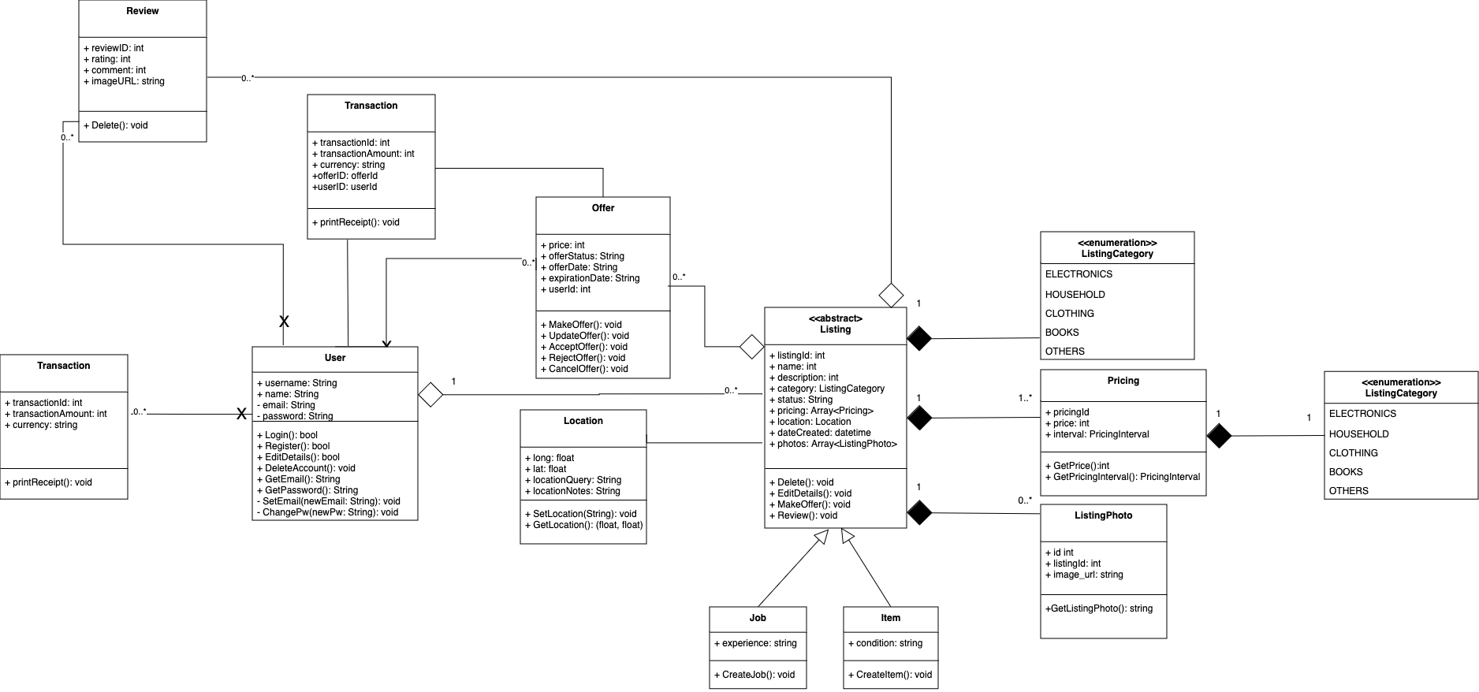

## 4.0 State Machine Diagram

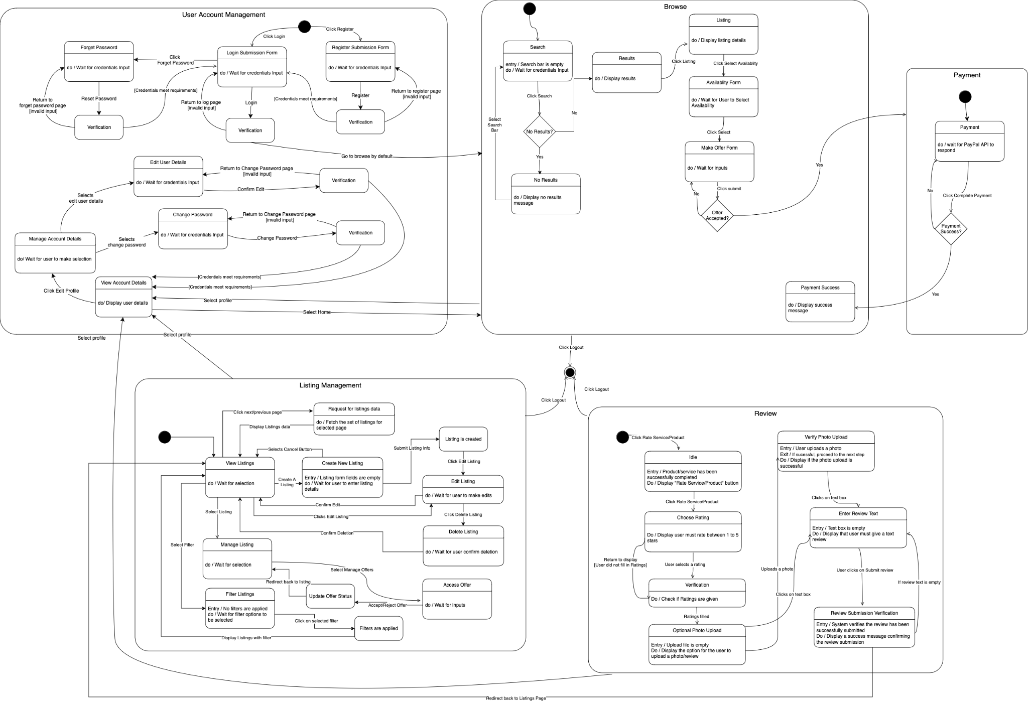

## 5.0 Sequence Diagram

### 5.1 Account Management

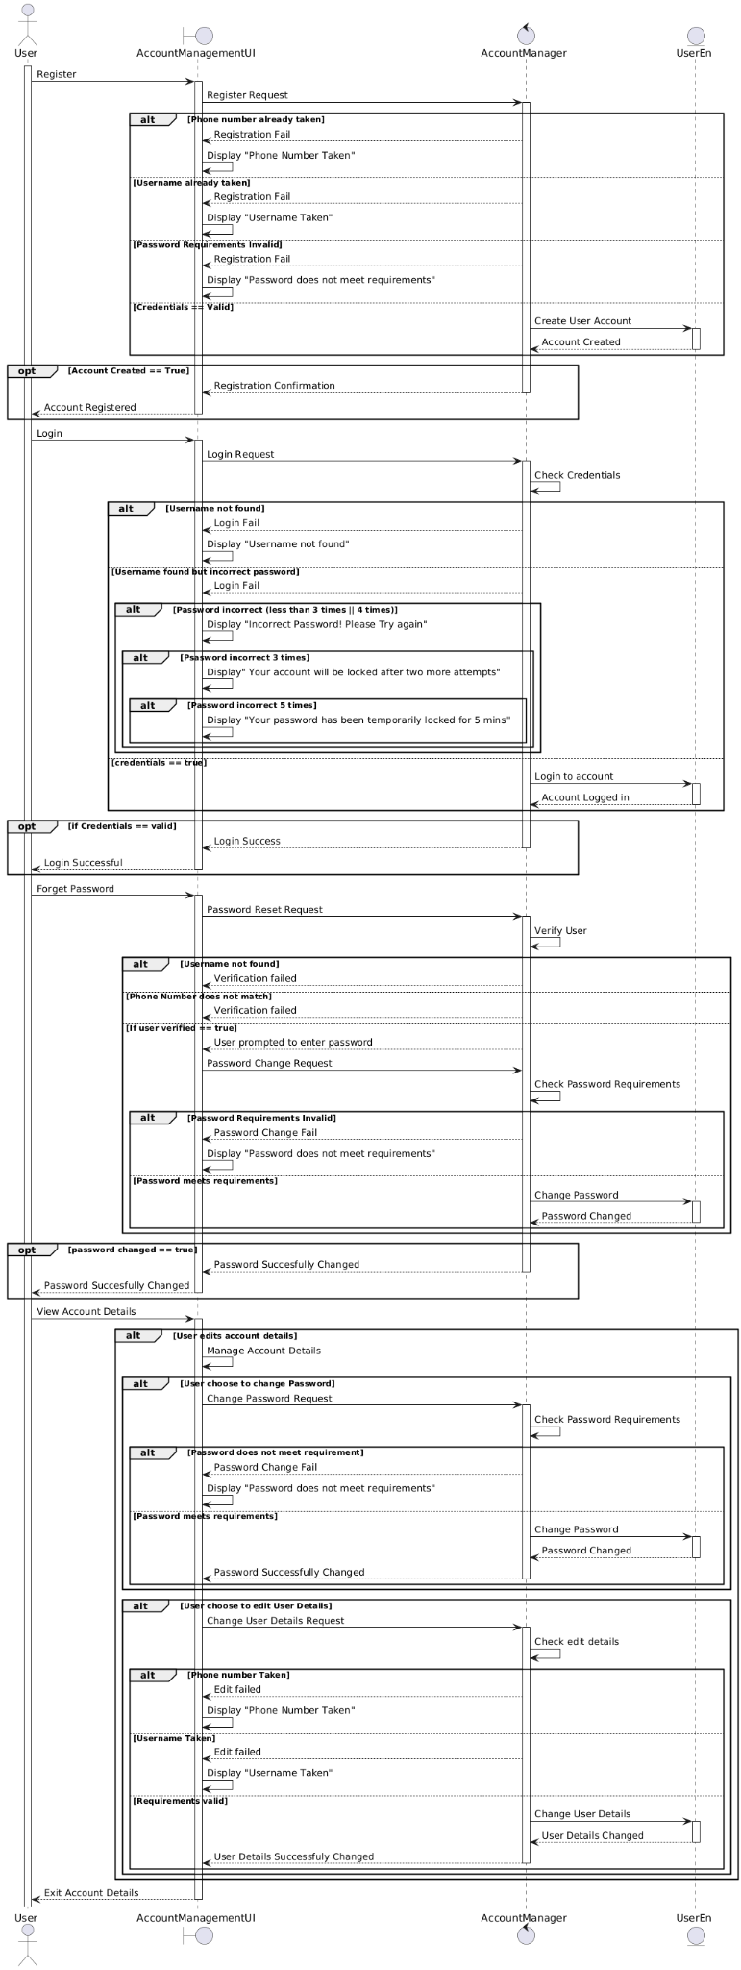



### 5.2 Browse

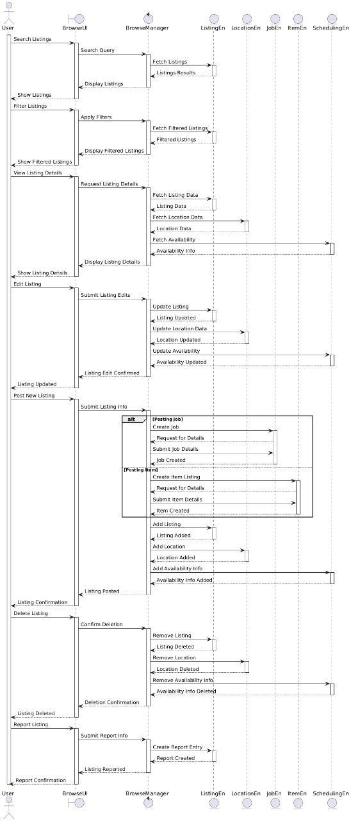

### 5.3 Offer

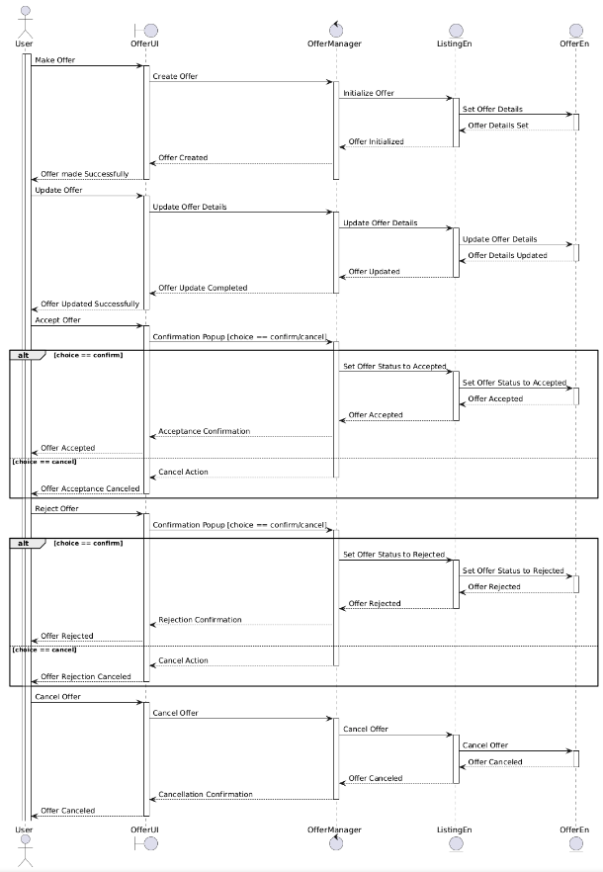

### 5.4 Review

